# MS Office Excel (Project 2A)

Hey everyone - welcome back! In my first two tutorials, I created a simple worksheet and chart. I also created formulas using relative and absolute cell references. But now, I went more in depth and applied complex calculations to my data. I also added sort and filter features to this data, based on certain criteria.

I worked with the data for Rosedale Landscape & Garden. Rosedale Landscape & Garden grows and sells trees and plants across North America. For 75 years, the company has introduced many new plants for the enjoyment of home gardeners. The company has nurseries and stores throughout the US and Canada. In addition to high-quality plants and trees, Rosedale sells garden tools and outdoor furniture. Rosedale also offers professional landscape design and installation for both commercial and residential clients. The company headquarters is in Pasadena, CA. Holman Hill is the President of Rosedale Landscape and Garden. He wants to know the current inventory of trees at the Pasadena nursery. So, I created a worksheet for him.

First, I highlighted column C, right clicked, and selected “Insert”. This inserted two new blank columns. In cell C11, I typed in “13129”. Then, I navigated to the “Home” tab, went to the “Editing” group, clicked “Fill”, and selected “Flash Fill”. This automatically filled in my item numbers for me. I repeated this step for cell D11 when I typed in “Oak” for that cell. Then, I deleted column B. Next, I typed “Item #” in cell B10. Afterwards, I highlighted column C, right clicked, and selected “Cut”. Then, I selected cell H1, right-clicked again, and chose “Paste”. Since column C is blank, I cut and deleted it. So now, my spreadsheet looks like this.

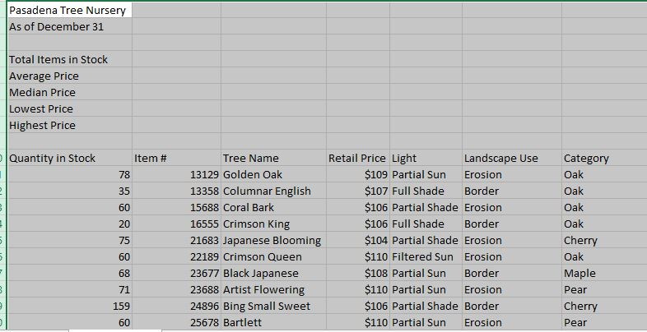

After I deleted column C, I highlighted columns A through G and auto formatted the content. Then, I merged and centered the title, “Pasadena Tree Nursery” and formatted the title with the “Title” cell style.

Next, I used the SUM and AVERAGE functions to gather information about the product inventory. I clicked cell B4, navigated to the “Formulas” tab, went to the “Function Library” group, and clicked the upper portion of the AutoSum button. When I clicked on “Sum”, my formula got automatically populated. So, my sum formula looked like this:

=SUM(A11:A39)

I formatted my value in cell B4 as a number with the comma separator. To do this, I navigated to the “Home” tab, went to the “Number” group, clicked on the arrow in the lower right-hand corner, and checked off the “Use 1000 Separator (,)” in the “Format Cells” pop-up window.

I repeated this process for the average, median, lowest, and highest prices. The median function found my middle value that has as many values above it in the group as below. The process was the same. But the differences were which cell range and formulas I used. In cells B5, B6, B7, & B8, my formulas looked like this:

=AVERAGE(B11:B39)

=MEDIAN(B11:B39)

=MIN(B11:B39)

=MAX(B11:B39)

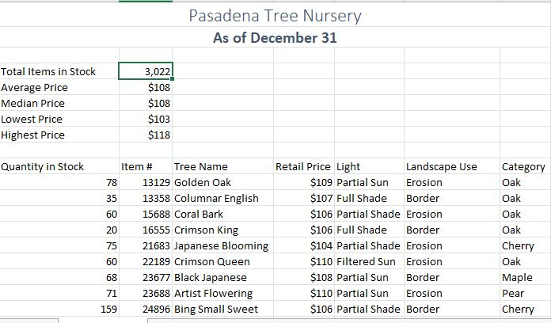

After I added in my functions, I moved and rotated text. When I move a formula, the cell references in the formula don’t change, no matter what type of cell reference I use. First, I selected column E and set the width to 50 pixels. Then, I highlighted the range from A4 to B8. Next, I moved the range from A4 to B8 to D4 to E8. Then, I autofitted the content in my spreadsheet and formatted the range with a cell style of “20%-Accent1”.

Before I rotated my text, the first thing I did was type “Tree Statistics” in cell C6. I navigated to the “Home” tab, went to the font group, and clicked on the “B” and “I” buttons to set the font to bold italic. I also went to the “Font Size” drop-down menu and increased the font size to “14”. When I set the color of my font, I clicked on the arrow in the lower-right hand corner of the “Font” group to open up my “Format Cells” pop-up window. Then, I chose the first color of the fifth column in the “Font Color” drop-down menu, “Blue, Accent 1”. I also checked off the “Merge cells” check box. On the last step to rotate my text, I navigated to the “Alignment” tab in the 'Format Cells” pop-up window, selected “Right” in the “Horizontal” drop-down menu, and typed in “30” for “Degrees” under “Orientation”.

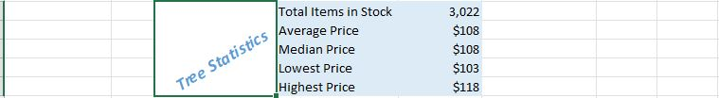

After I rotated my text, I right clicked on row 9 and inserted three blank new rows. Now, this is where the COUNT and COUNTIF functions will come in. COUNT counts the number of cells in a range that contain numbers. COUNTIF counts the number of cells within a range that meet the given condition, based on the provided criteria. Rosedale Landscape and Garden will be featured on an upcoming segment of a TV gardening show. The company wanted me to determine the number of Oak trees currently available in inventory that can be featured in the TV show. So, that’s where the COUNTIF function came in. In cell A10, I typed “Oak Trees” and pressed “Tab”. In cell B10, I navigated to the “Formulas” tab, went to the “Function Library” group, clicked on “More Functions”, selected “Statistical” and chose “COUNTIF”. When I chose “COUNTIF”, I got a “Functions Argument” pop-up window. I set “Range” as “G14:G42” and “Criteria” as “Oak”.

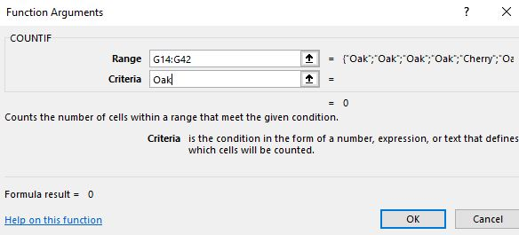

When I clicked “OK”, it showed me that there are 13 different Oak trees. I repeated this step to evaluate the inventory levels and determine if more products need to be ordered. But this time, I used the IF function. A logical test is any value or expression that I can evaluate as being true or false. The IF function uses a logical test to check whether a condition is met, and then returns one value if it’s true, and a different value if it’s false. In cell H13, I typed “Stock Level” and pressed “Enter”. In cell H14, I followed the same steps as I did to add my COUNTIF function. I set “Logical_test” to “A14<75”, “Value_if_true” to “Order”, and “Value_if_false” to “OK”. This told me if the result of the logical test is false, meaning if the Quantity in Stock is not less than 75, then Excel showed as OK in the cell.

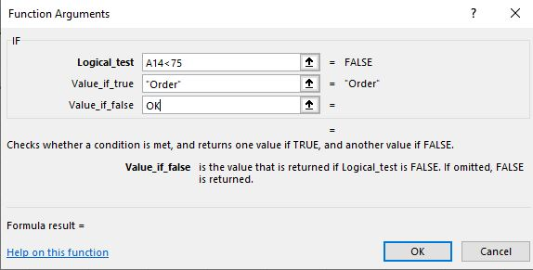

After I clicked “OK”, the result of “OK” showed up in cell B14. Then, I used the fill handle to drag and drop the formula down from cell B14 to cell B42.

The next feature I added was conditional formatting. Conditional formatting lets me analyze data and identify patterns and trends in a specific set of data. A conditional format changes the appearance of a cell based on criteria. If the condition is true, the cell is formatted based on that condition. If the condition is false, then the cell is not formatted. I used conditional formatting to highlight the Stock Level of trees. I highlighted the range from H14 to H42, navigated to the “Home” tab, went to the “Styles” group, clicked on “Conditional Formatting”, selected “Highlight Cell Rules” and chose “Text That Contains”. When I clicked on “Text That Contains”, I got a “Text That Contains” pop-up window. In the pop-up window, I typed “Order”, clicked on the arrow, and chose “Custom Format”. When I chose “Custom Format”, I got a “Format Cells” pop-up window. I set the “Font style” to “Bold Italic” and the “Color” to the first color in the last column, “Green, Accent 6”. Next, I applied data bars to the “Quantity in Stock” column. Data bars offer visual cues about the values of cells that are related to other cells. A longer bar represents a higher value, and a shorter bar represents a lower value. Data bars can identify higher and lower numbers quickly in a large group of data, like high or low levels of inventory. I selected the range of A14 to A42, navigated to the “Home” tab, went to the “Styles” group, clicked on “Conditional Formatting”, chose “Data Bars”, selected “Gradient Fill”, and clicked “Orange Data Bar”.

The second to last step I had left was to find and replace text. The “Find and Replace” feature searches the cells in a worksheet or selected range for matches and replaces each match with a replacement value that I choose. Comments from customers on the company’s blog indicate that using the term “Erosion Control” would be clearer than “Erosion” when describing the best landscape use for specific trees. I navigated to the “Home” tab, went to the “Editing” group, clicked “Find & Select”, and chose “Replace”. I typed “Erosion” in the “Find what” field. In the “Replace with” field, I typed “Erosion Control”. Then, I clicked on “Replace All”. When I clicked on “Replace All”, I got a pop-up window saying that Excel made 13 replacements.

My final step was to create and sort my table. When I analyze a group of related data, I can convert a range of cells to an Excel table. An Excel table is a series of rows and columns that contain related data. That data is managed independently from the data in other rows and columns in the worksheet. I clicked in any cell below row 13, navigated to the “Insert” tab, went to the “Tables” group, and clicked on “Create Table”. When I clicked on “Create Table”, I got a “Create Table” pop-up window. Next, I clicked on the “My table has headers” check box. This means that the column titles in row 13 will form my table headers.

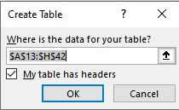

When I clicked “OK”, the headers got added to my table. I also got a new tab called “Table Tools”. Then, I navigated to the “Design” tab, went to the “Table Styles” group, clicked on “More”, chose “Light”, and selected “Table Style Light 16”. If I want to sort my data, I can click on the arrows and sort either in alphabetical order, reverse alphabetical order, smallest to largest, or largest to smallest. If I want to filter out data from my table, then I can click on the arrows and type in the text that I want my table to display.

So, this is how I applied complex calculations, along with sort and filter features to my data. Hope this tutorial was helpful! I’ll see you in the next one!